Niki Shirey and Joshua Pollock

Lab 06 Banners

27 October 2016

Lab Section 1

**Problem Statement:**

This lab is asking us to create a function that asks a user for two inputs. These two inputs are:

* A string
* An orientation

With these the function is to convert the string into banner made up of number symbols. We are required to make each banner letter at least 4 tall. We will assume that the user will only enter ‘horizontal’ or ‘vertical’ for orientation. We will also assume that the user will not use any numbers or symbols in their inputted string.

**Planning:**

Before we started we wanted to plan on what methods we would use for this lab. We came up with a short list of things that we would use. This list was:

* For statements
* Dictionaries
* Lists
* Input commands
* If statements
* Print commands

With these various items, we began to design our letters. At first we thought that a 3x4 letter would be fine. We soon found with a bit of drawing, that this would not work out for letters such as ‘M’ or ‘N’. We changed them to 5 tall and decided to not have a width constraint. This decision would make it easier to design more complex letters.

Dictionaries were a must for this lab. We concluded that dictionaries would be the easiest way to take in a string and convert that string into the desired banner.

**Implementation and Testing:**

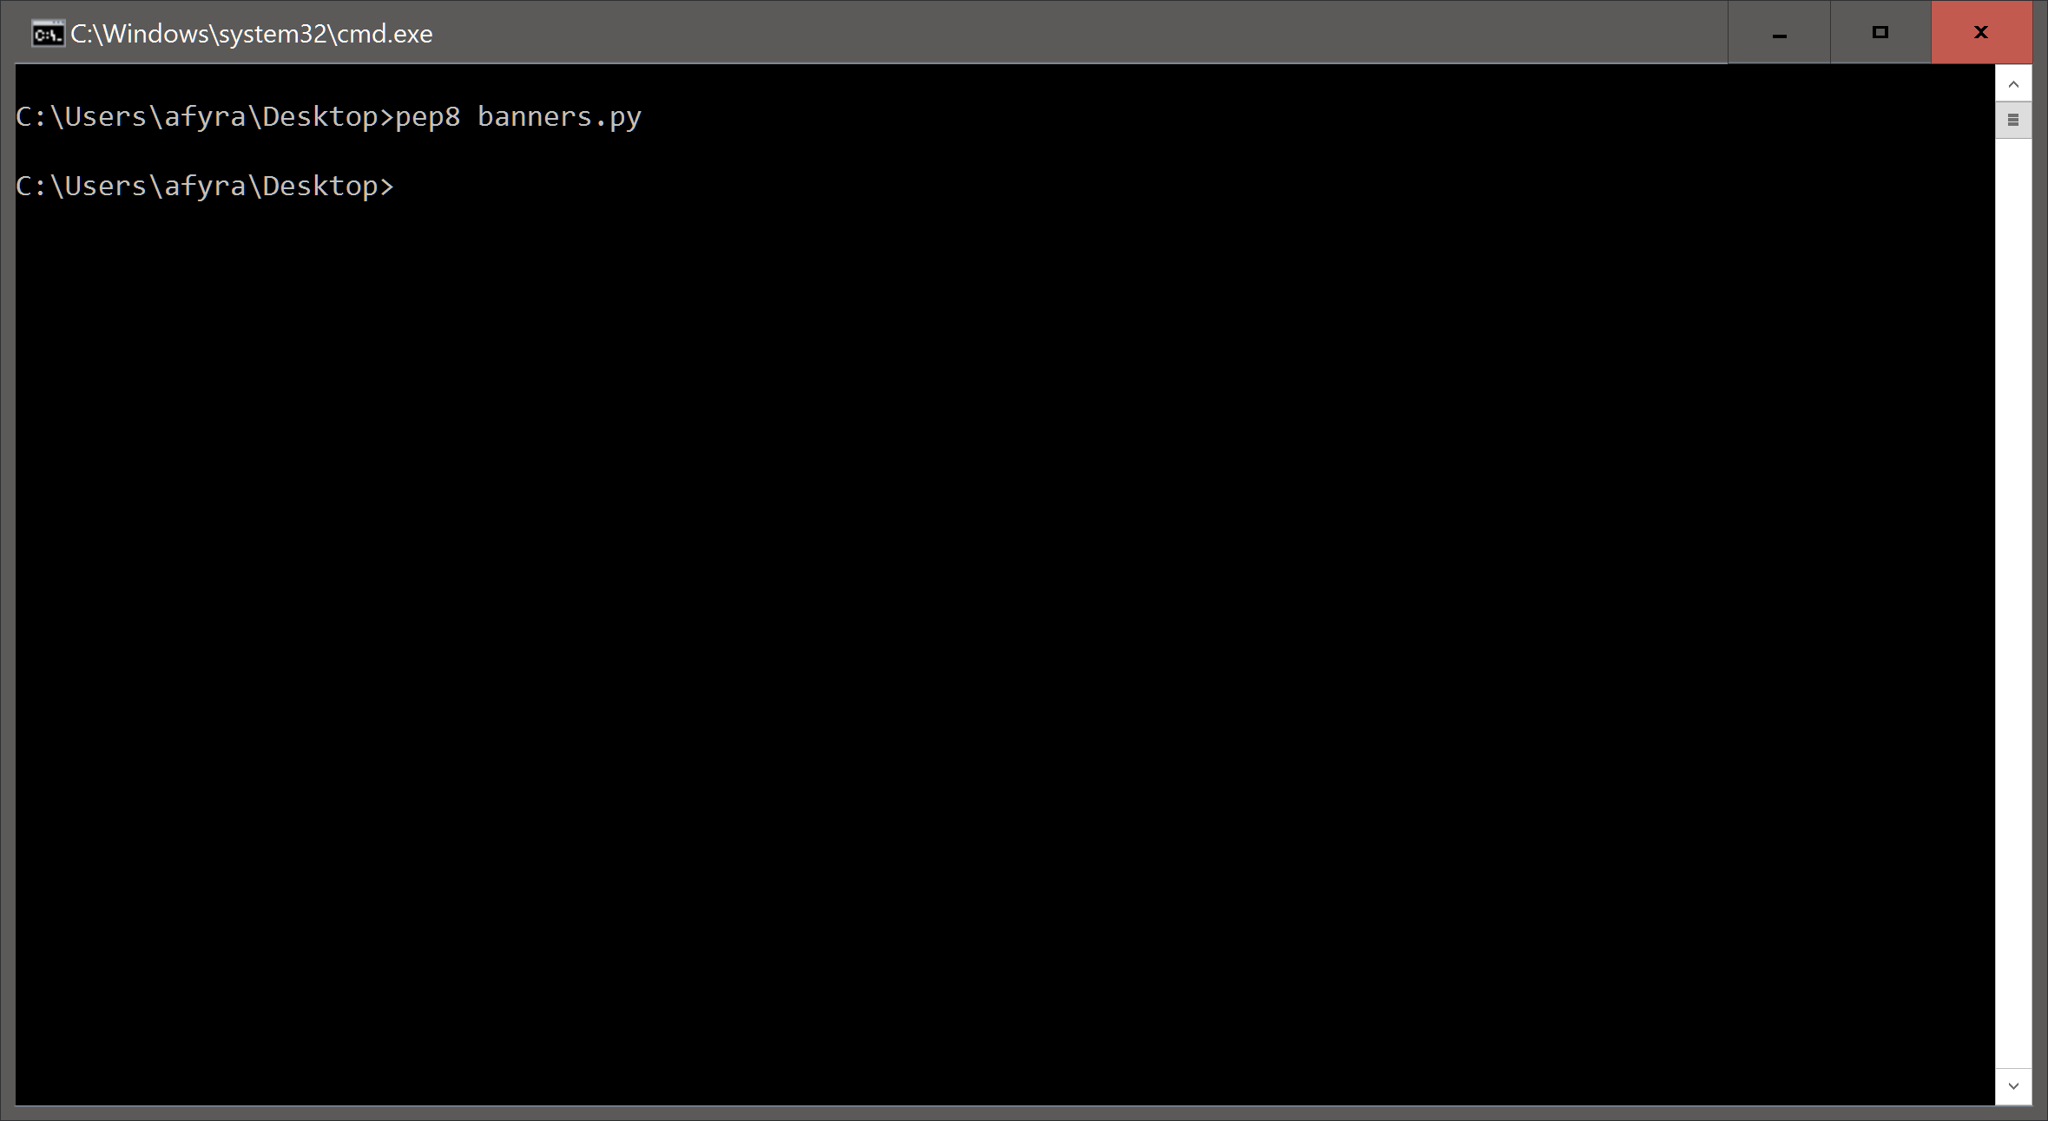

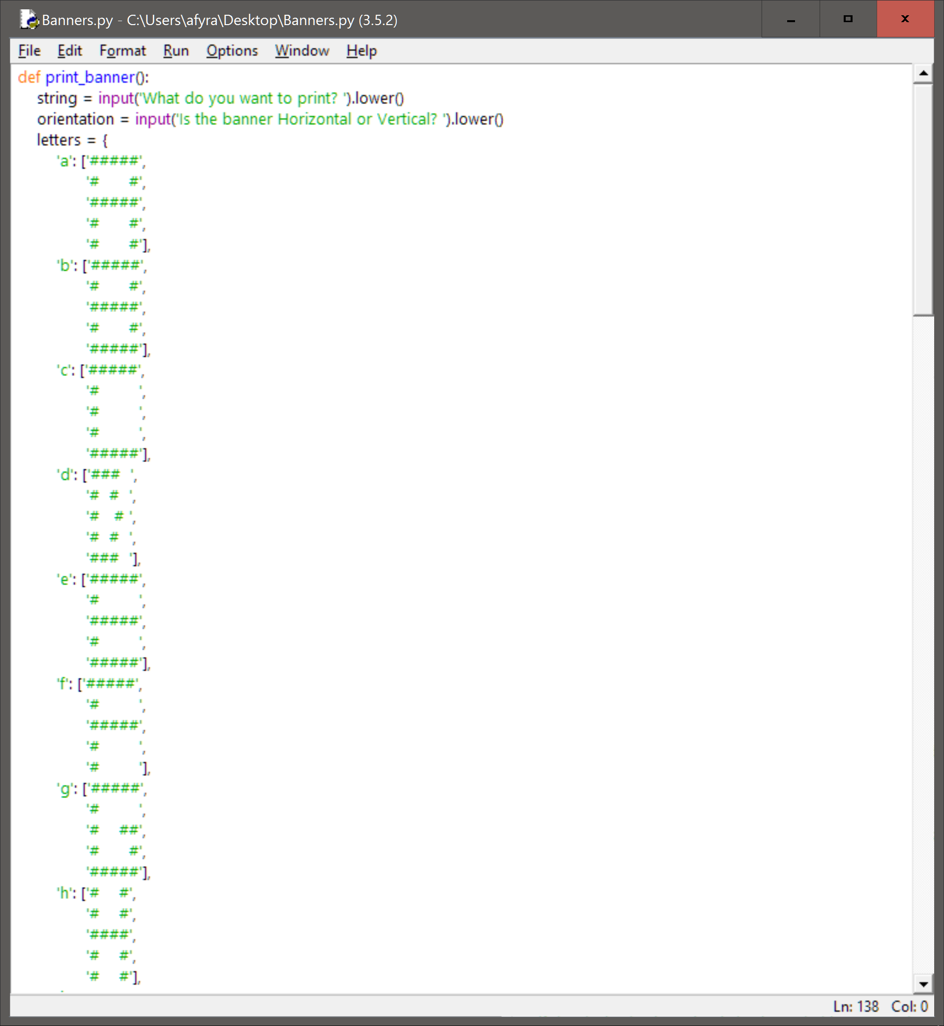

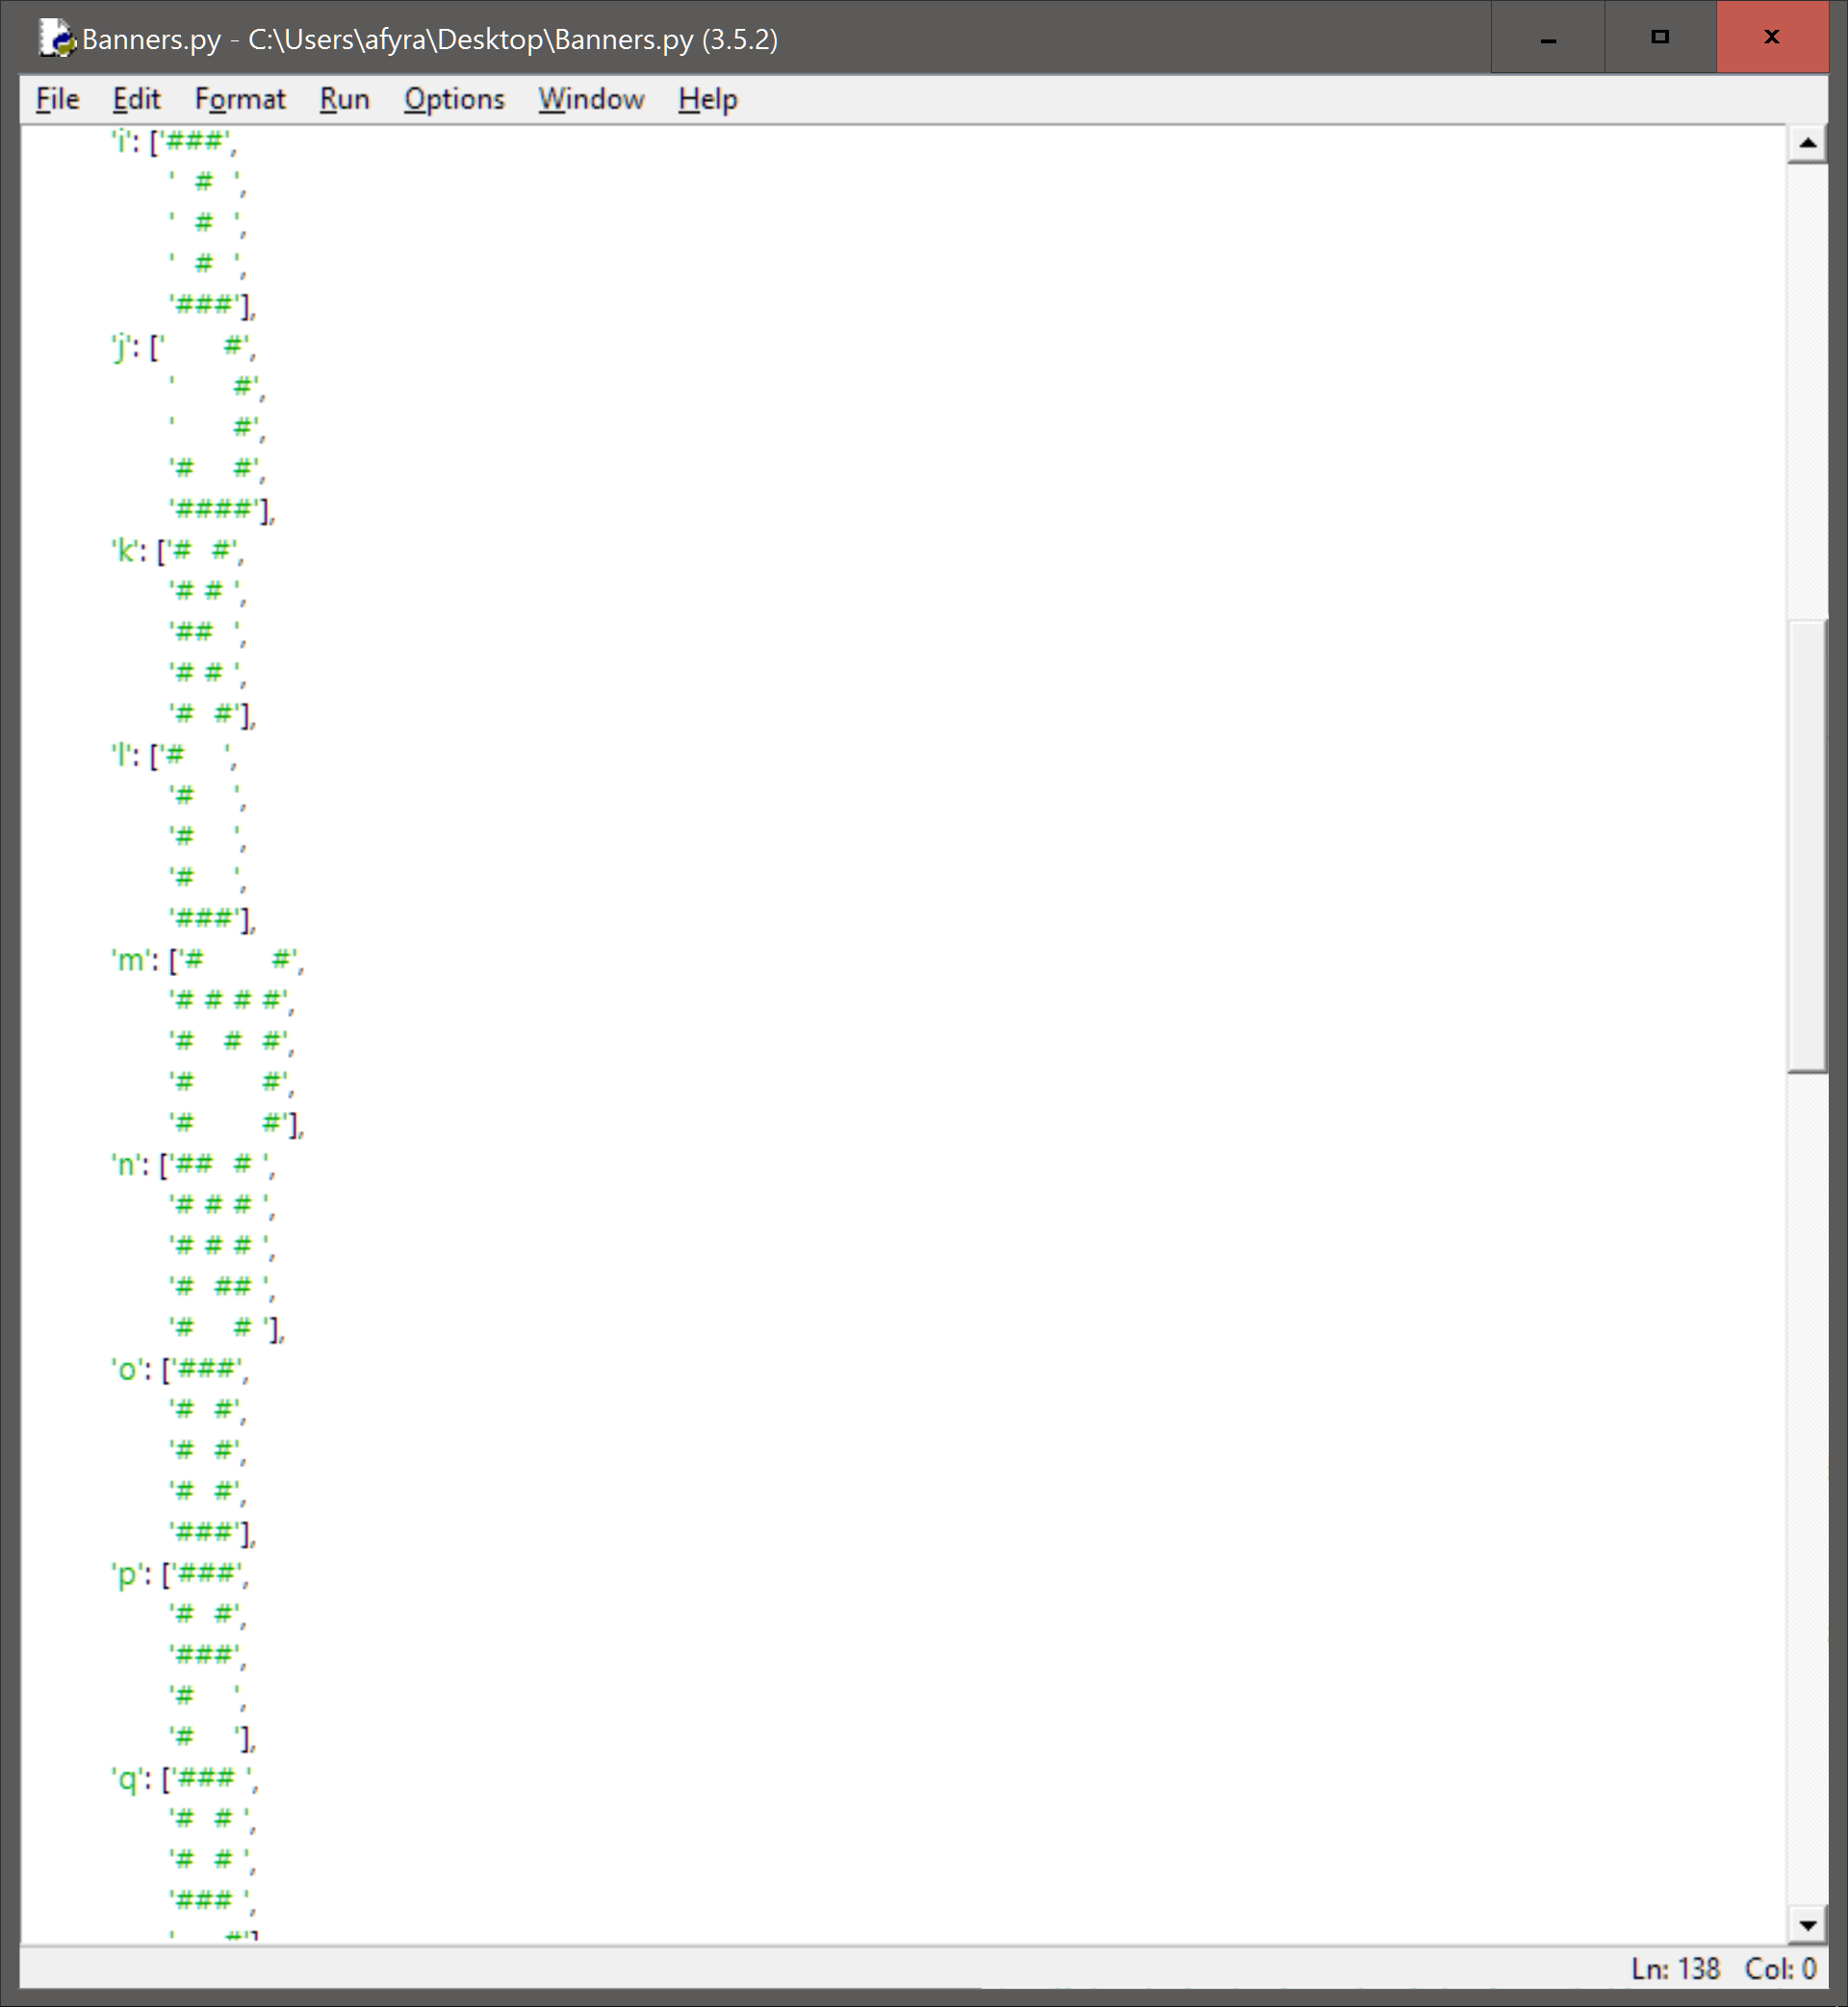

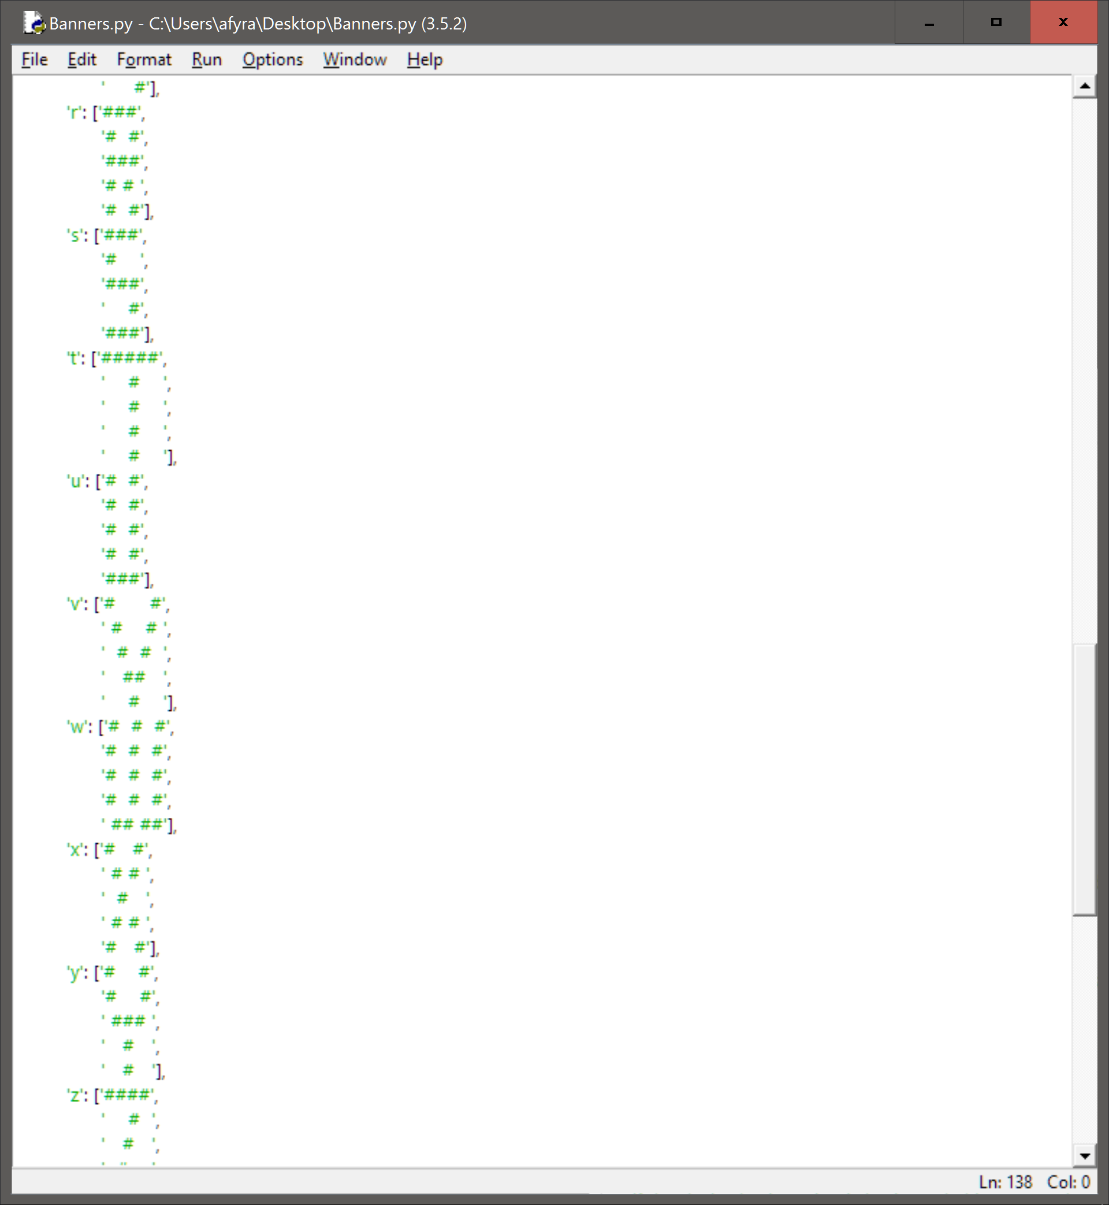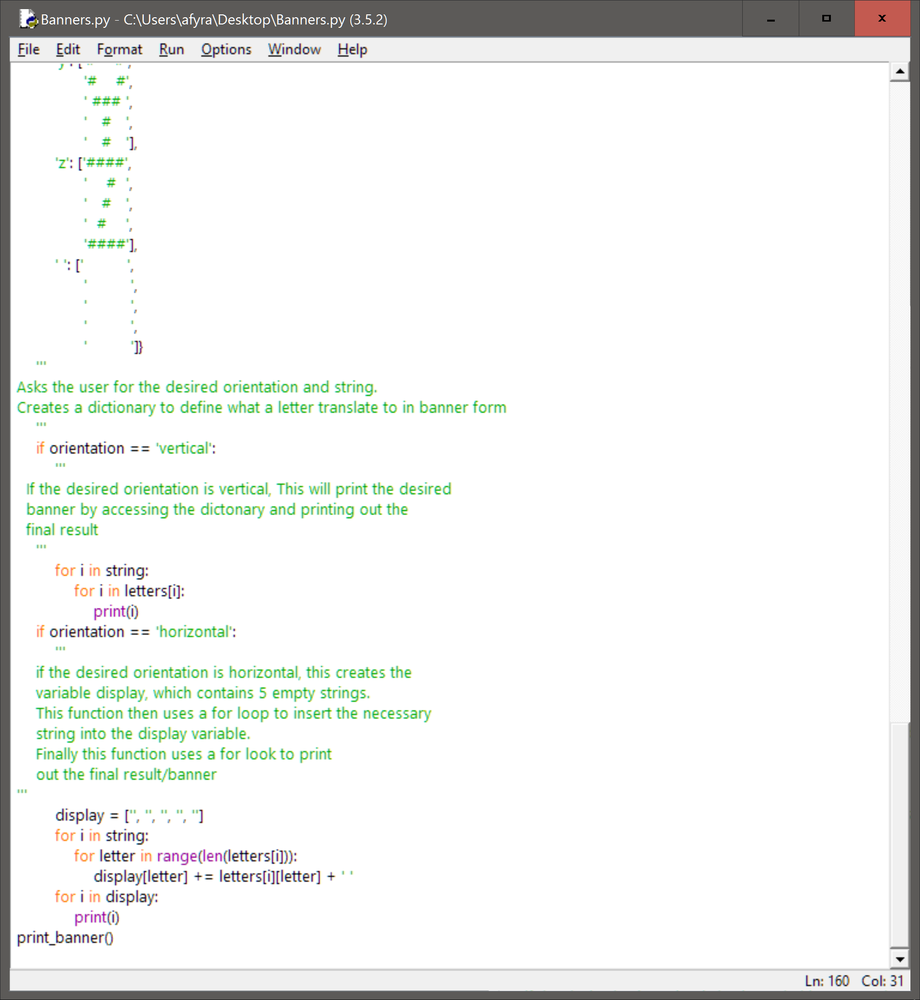

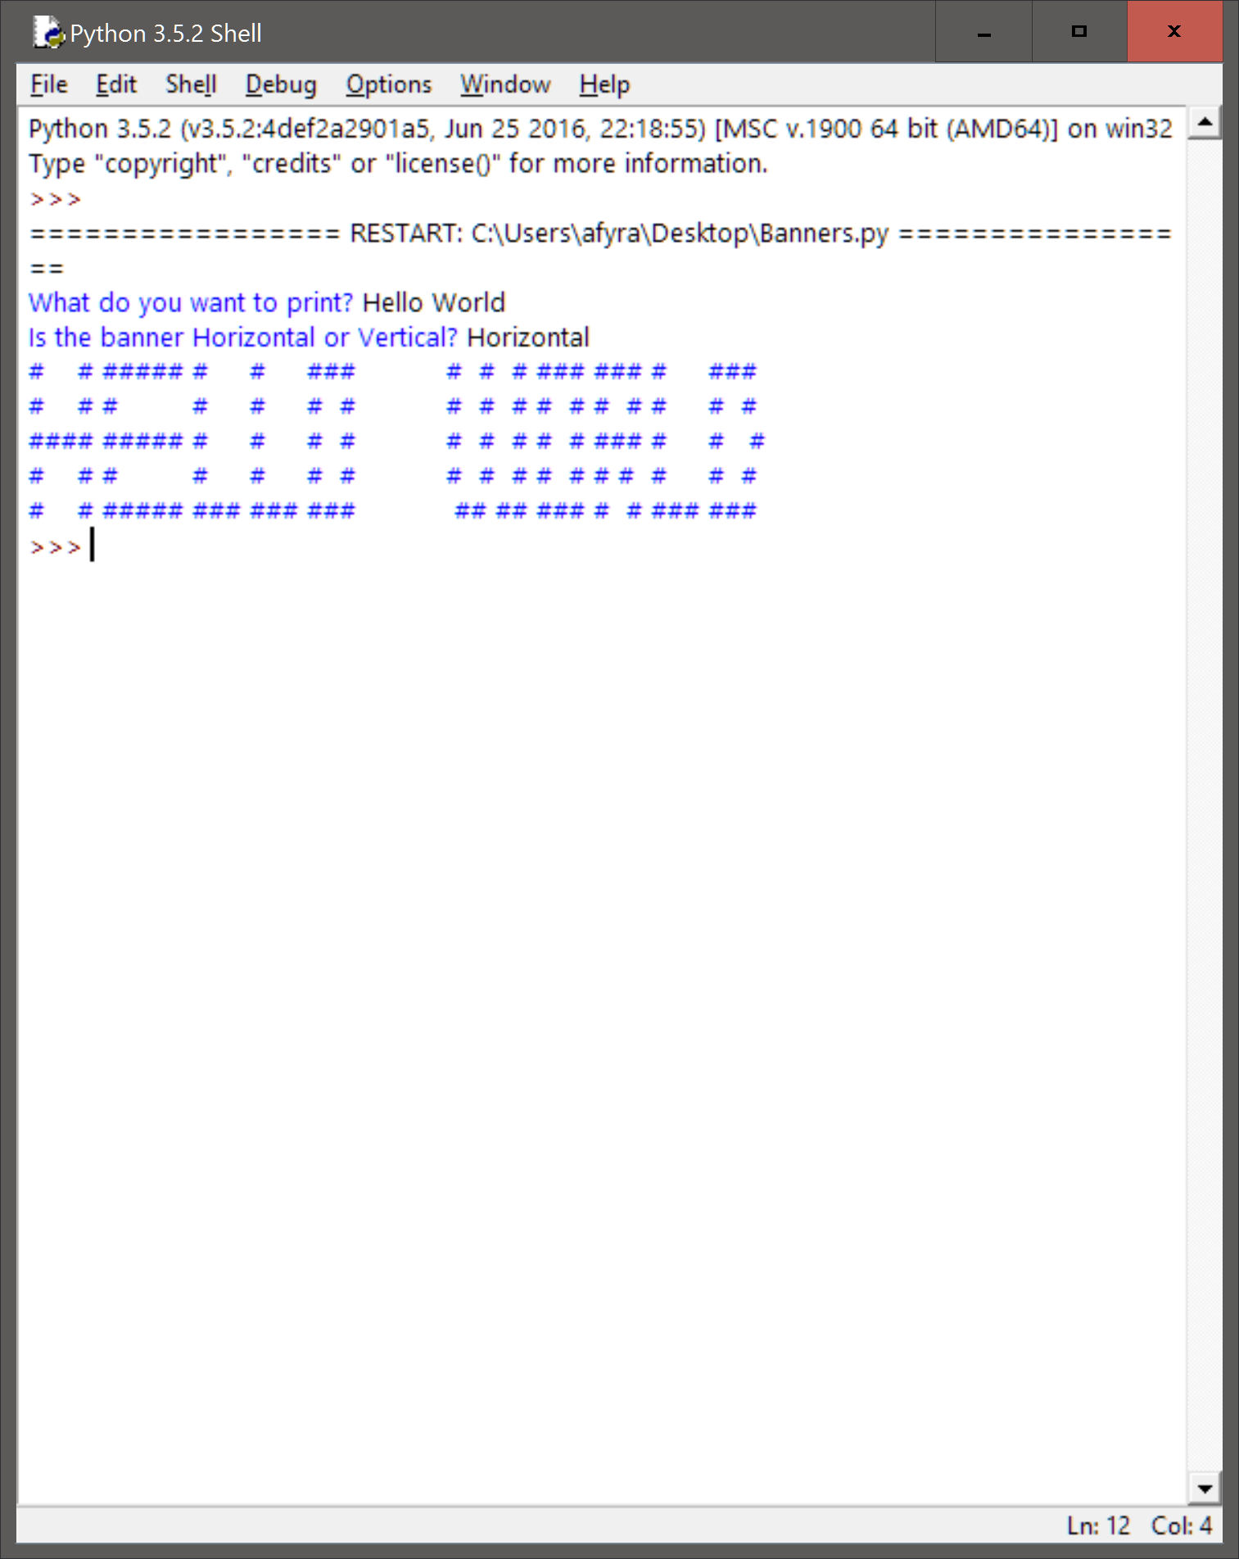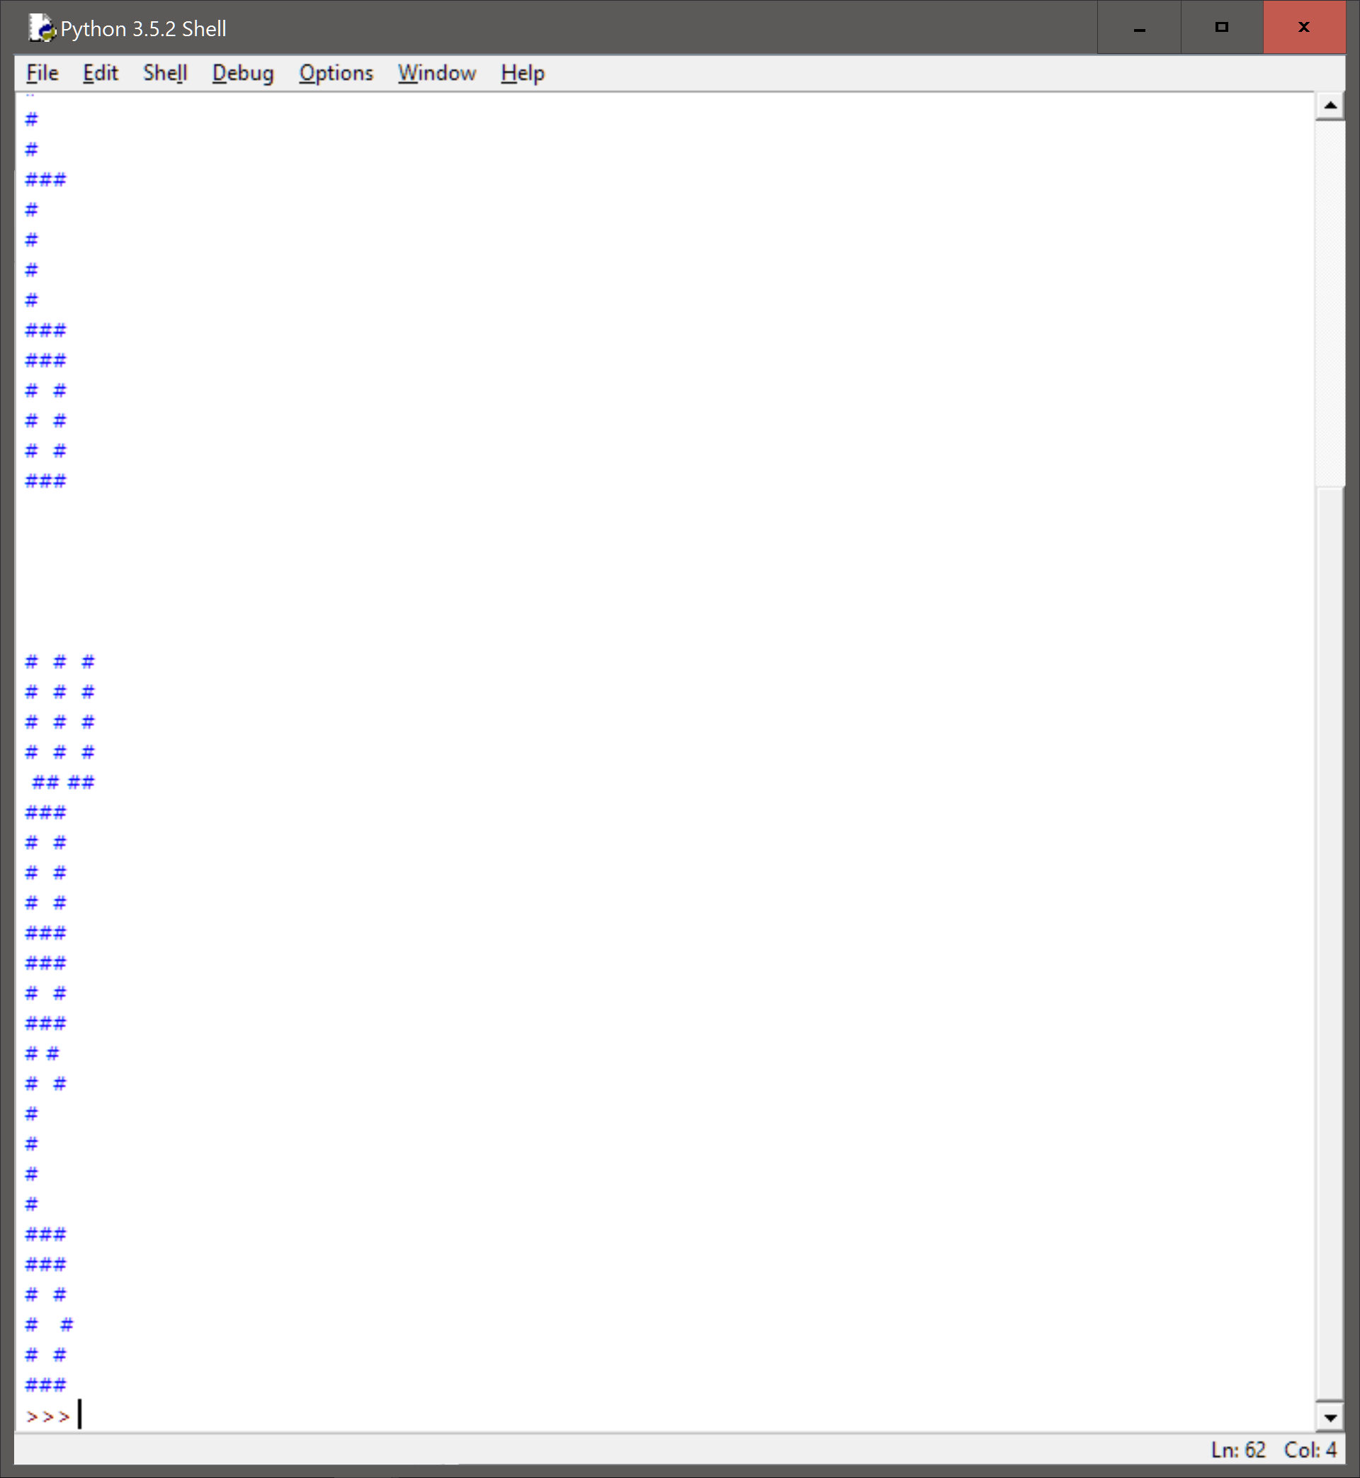

**Reflection and Refactoring:**

At first we set up our dictionary using the new line command (\n). This proved to be quite difficult to use for the horizontal output. We changed them to lists in order to manipulate them much easier without having to use the .split() command. As mentioned above, we also changed the way we designed the banner letters. We decided going 5 tall and ditched the idea of having a set width. This proved to be a great decision and made the output look much neater. There are still ways to refactor this code. The current variable names are not that good. We should try to change these to something more understandable to someone that just picks up our code. The doc string comments are also quite vague. These could be improved to include much more detail.

Overall, we are very satisfied with this code and find it to be a very viable solution to the given problem.